School District No. 43Coquitlam

COQUITLAM RIVER ELEMENTARY SCHOOL
4250 Shaughnessy St. Port Coquitlam BC V3E 3E5 Ph 604.942.0241 Fax 604.942.5941

SCHOOL TENNIS PROGRAM
April 17th
Dear Parent/Guardian:

Coquitlam River is pleased to again offer a unique, in-school tennis instruction program at the end of this month (April 29 to May 3). This program will take place during instructional time and is designed for elementary students from Kindergarten through Grade Five. All classes at CRE will have 3 sessions with Marcus, the tennis instructor. Marcus is an enthusiastic and skilled instructor whom our students greatly enjoyed last year!

The proper fundamentals are taught within a fun and playful environment. The program is designed by Tennis Canada and is offered to introduce the excellent sport of tennis to children. Tennis can be played indoors and outdoors, on grass, carpet, clay and cement, in Canada or anywhere in the world by anyone from ages 5 to 85+. We very much appreciate the benefits of this program and are optimistic that your child will participate.

No student will be denied access to this activity due to an inability to pay.
Please contact Mr. Peters to discuss a fee waiver.

Please fill out the form below and return it to the school by Tuesday, April 23rd.
Lessons will be held during the week of Apr 29th.
THE PROGRAM:
- Three lessons
- All tennis equipment provided
- Tennis Canada Certified Instructors
- Tennis Canada Action Method – No Waiting Around
- Only $7.00 per child. Marcus has agreed to charge us the same rate as last year.
- Students are to wear comfortable pants/shorts, t-shirt and running shoes (no dresses/skirts or jewellery)
- Focus on the three C’s: Coordination, Concentration and Cooperation
- It’s fun, it’s fast, it’s for you!

Thank you,
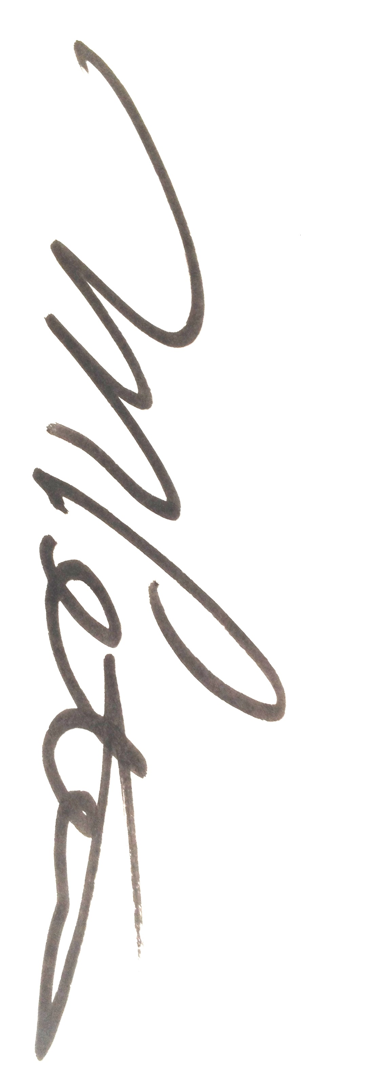
M. Peters, Principal

-----------------------------------------------------------------------------------------------
PARENT/GUARDIAN PAYMENT - CRE TENNIS PROGRAM

Name of child: _____________________________________ Age: _____ Div: ____

Name of Parent/Guardian: ______________________Signature:__________________
- I have included $7.00 for the lessons.

*There will be an opportunity to purchase a new tennis racquet at a reduced price. Samples will be available for viewing at the office. A notice will be sent home with further information.

Please make cheques payable to Coquitlam River Elementary School.
S.D. 43 requires each student participating in an event receive this written consent from their parent(s)/guardian(s) in order for their child to participate; and also wishes to advise any risk of injury associated with the activity.

